Claire Homard  Chief Officer (Education and Youth)  Prif Swyddog (Addysg ac leuenctid) | 
To All Clerks  Flintshire Town and Community Councils | Your Ref/Eich Cyf
To All Clerks  Flintshire Town and Community Councils | Our Ref/Ein Cyf | CH/PS2020
To All Clerks  Flintshire Town and Community Councils | Date/Dyddiad | 26th March 2020
To All Clerks  Flintshire Town and Community Councils | Ask for/Gofynner am | Claire Homard
To All Clerks  Flintshire Town and Community Councils | Direct Dial/Rhif Union | 01352 704190

Dear Clerk,

Cancellation of Summer Play Schemes – Covid -19

Flintshire County Council has taken the difficult but necessary decision to cancel all play schemes in the County during the summer holidays this year.

This is for two reasons - Welsh Government has placed the funding from the Holiday Hunger Playworks Grant ‘on hold’ given the current crisis and it is also due to the challenge in manging social distancing and gathering rules.

If you have any further queries please do not hesitate to contact Janet Roberts, Play Manager janet.a.roberts@flintshire.gov.uk

Yours sincerely
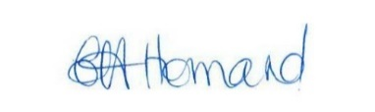

Claire Homard
Chief Officer, Education & Youth

